About: With over 35 years of industry experience, SS Airtech Solutions provides reliable and energy-efficient compressed air and energy management solutions that improve productivity, reduce operating costs, and enhance equipment performance.

Our SOLLANT Partnership: Shanghai SOLLANT Energy Saving Technology Co., Ltd. is a leading manufacturer of energy-efficient compressed air systems, offering high-performance solutions for diverse industrial applications.

SOLLANT Product Range
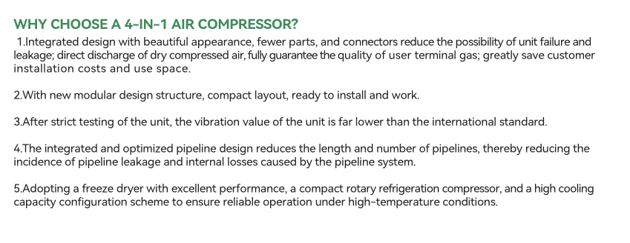
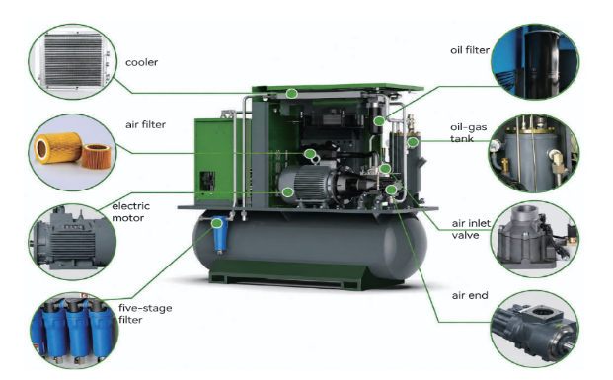
- Fixed Speed & PM VSD Screw Compressors I Two-Stage PM VSD Compressors I Air Dryers, Filters & Air Treatment Systems I Genuine Spare Parts I Complete Compressed Air System Solutions I Reliable Air—Lower Energy. Better Performance.
4 -IN-1 AIR COMPRESSOR
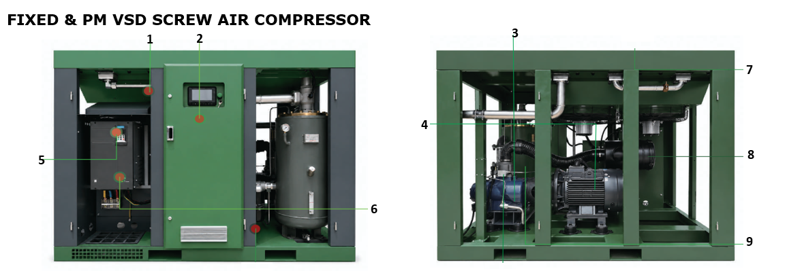
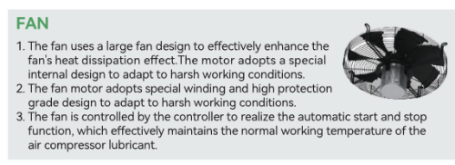
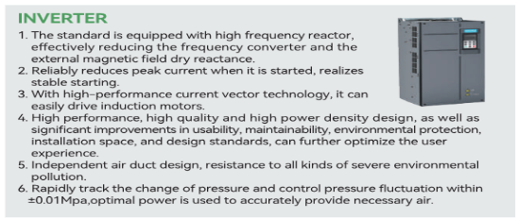
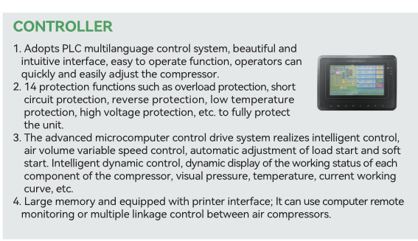
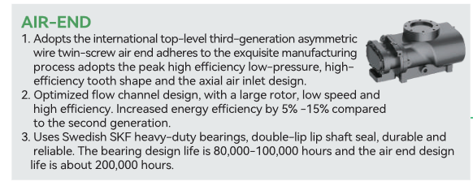
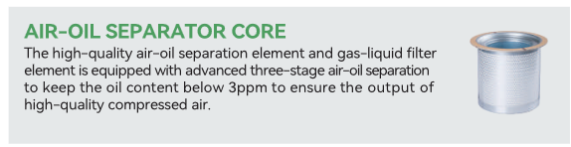
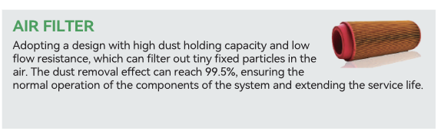
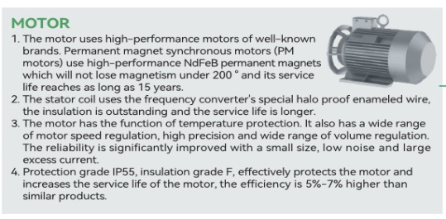
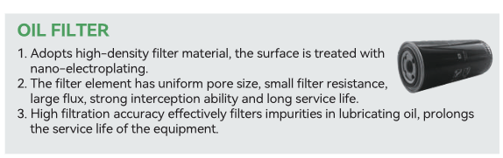
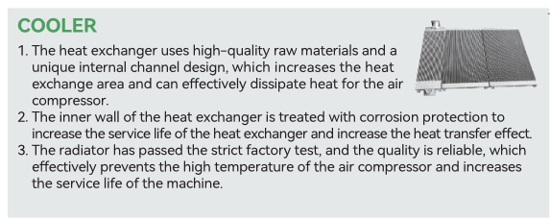

FIXED & PM VFD SPEED SCREW AIR COMPRESSOR
